**Ragul S V**

**CB.EN.U4CSE17348**

**Q1)**

**Screenshot:**

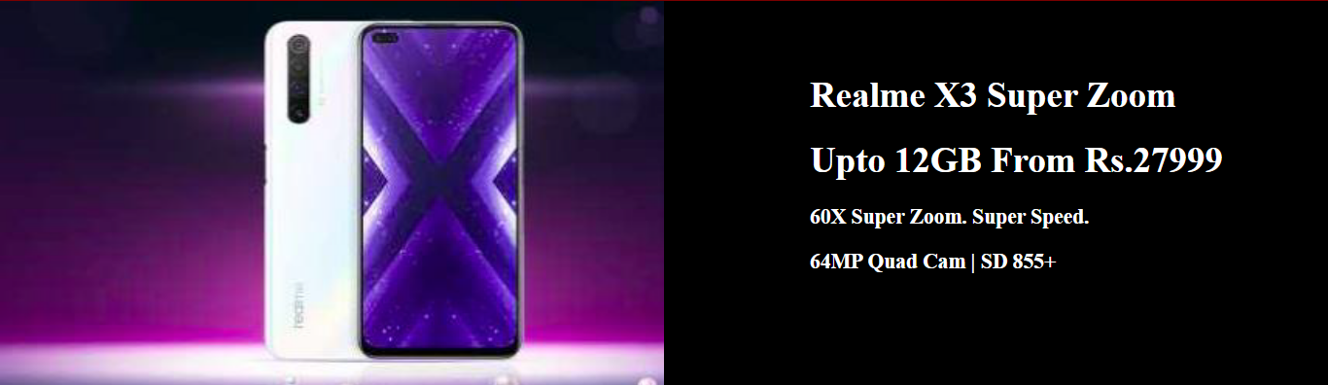

**Code:**

<!DOCTYPE html>

<html>

<head>

<title>Q1</title>

<style>

body{

padding:0px;

margin:0px;

}

</style>

</head>

<body>

<img src="phone.png" style="width:50%;height:400px;">

<div style="position:relative;color:white;float:right;width:50%;height:350px;

background-color: black;padding-top:50px;font-size:1.15em;">

<h1 style="padding-left:150px;">Realme X3 Super Zoom</h1>

<h1 style="padding-left:150px;">Upto 12GB From Rs.27999</h1>

<h3 style="padding-left:150px;">60X Super Zoom. Super Speed.</h1>

<h3 style="padding-left:150px;">64MP Quad Cam | SD 855+</h1>

</div>

</body>

</html>

**Q2)**

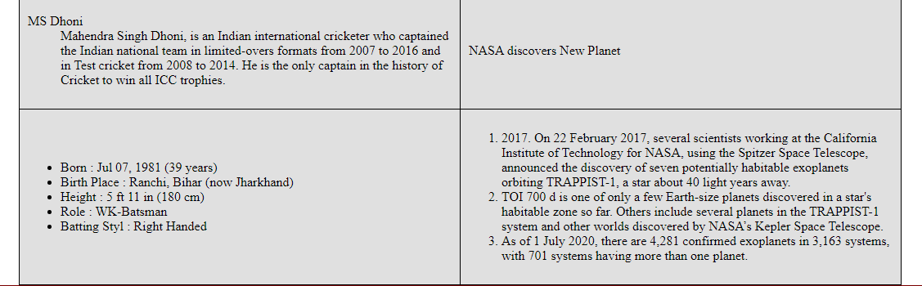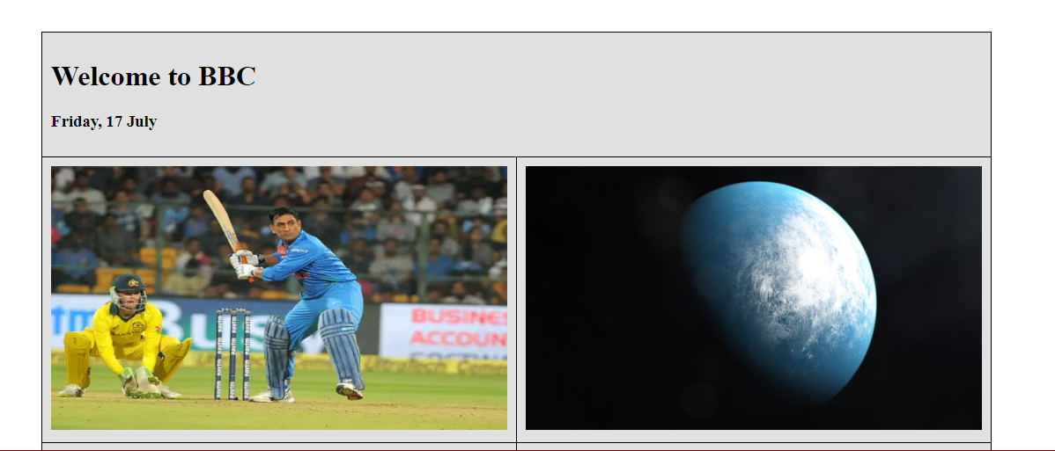**Screenshot:**

**Code:**

<!DOCTYPE html>

<html>

<head>

<title>Q2</title>

<style>

body{

padding:0px;

margin:0px;

}

table,tr,td{

border: 1px solid black;

border-collapse: collapse;

padding:10px;

}

</style>

</head>

<body>

<table style="width:80%;margin:auto;margin-top:100px;background-color:#E0E0E0;">

<tr>

<td colspan="3">

<div>

<h1>Welcome to BBC</h1>

<h3>Friday, 17 July</h3>

</div>

</td>

</tr>

<tr>

<td style="width:50%;"><img src="dhoni.png" style="width:100%;height:300px;"></td>

<td style="width:50%;"><img src="planet.png" style="width:100%;height:300px;"></td>

</tr>

<tr>

<td>

<dl>

<dt>MS Dhoni</dt>

<dd>Mahendra Singh Dhoni, is an Indian international cricketer who captained the Indian national team in limited-overs formats from 2007 to 2016 and in Test cricket from 2008 to 2014. He is the only captain in the history of Cricket to win all ICC trophies. </dd>

</dl>

</td>

<td>NASA discovers New Planet</td>

</tr>

<tr>

<td>

<ul>

<li>Born : Jul 07, 1981 (39 years)</li>

<li>Birth Place : Ranchi, Bihar (now Jharkhand)</li>

<li>Height : 5 ft 11 in (180 cm)</li>

<li>Role : WK-Batsman</li>

<li>Batting Styl : Right Handed</li>

</ul>

</td>

<td>

<ol>

<li>2017. On 22 February 2017, several scientists working at the California Institute of Technology for NASA, using the Spitzer Space Telescope, announced the discovery of seven potentially habitable exoplanets orbiting TRAPPIST-1, a star about 40 light years away.</li>

<li>TOI 700 d is one of only a few Earth-size planets discovered in a star's habitable zone so far. Others include several planets in the TRAPPIST-1 system and other worlds discovered by NASA’s Kepler Space Telescope.</li>

<li>As of 1 July 2020, there are 4,281 confirmed exoplanets in 3,163 systems, with 701 systems having more than one planet.</li>

</ol>

</td>

</tr>

</table>

</body>

</html>

**Q3)**

**Screenshot:**

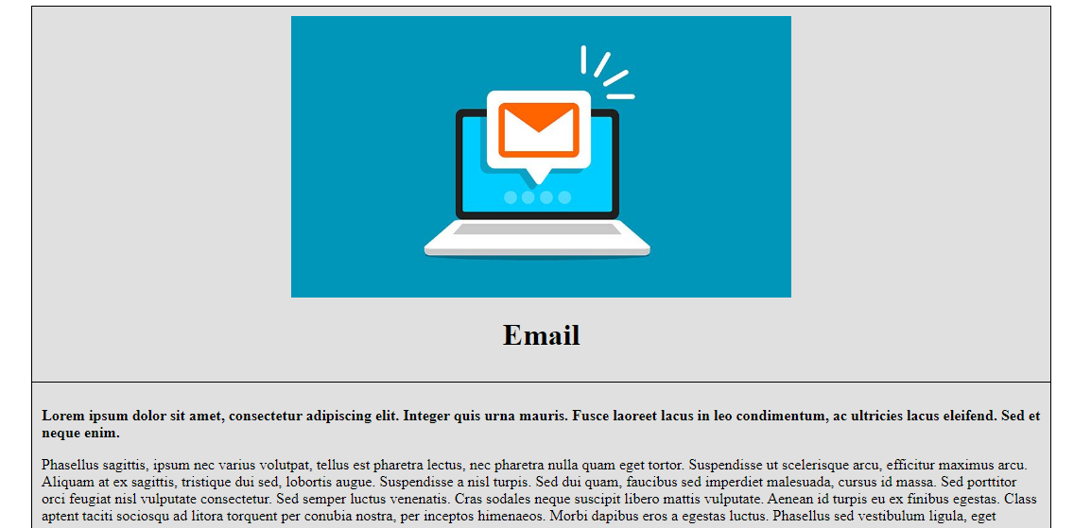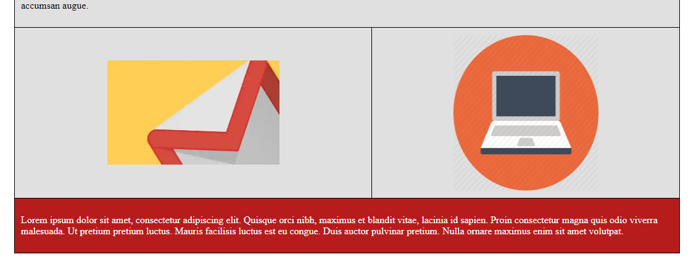

**Code:**

<!DOCTYPE html>

<html>

<head>

<title>Q3</title>

<style>

body{

padding:0px;

margin:0px;

}

table,tr,td{

border: 1px solid black;

border-collapse: collapse;

padding:10px;

}

</style>

</head>

<body>

<table style="width:80%;margin:auto;margin-top:100px;background-color:#E0E0E0;">

<tr style="text-align: center;">

<td colspan="2">

<img src="email.png" style="display:block;margin-left: auto;

margin-right: auto;width:50%;height:50%px;">

<h1>Email</h1>

</td>

</tr>

<tr>

<td colspan="2">

<p><strong>Lorem ipsum dolor sit amet, consectetur adipiscing elit. Integer quis urna mauris. Fusce laoreet lacus in leo condimentum, ac ultricies lacus eleifend. Sed et neque enim. </strong></p>

<p>Phasellus sagittis, ipsum nec varius volutpat, tellus est pharetra lectus, nec pharetra nulla quam eget tortor. Suspendisse ut scelerisque arcu, efficitur maximus arcu. Aliquam at ex sagittis, tristique dui sed, lobortis augue. Suspendisse a nisl turpis. Sed dui quam, faucibus sed imperdiet malesuada, cursus id massa. Sed porttitor orci feugiat nisl vulputate consectetur. Sed semper luctus venenatis. Cras sodales neque suscipit libero mattis vulputate. Aenean id turpis eu ex finibus egestas. Class aptent taciti sociosqu ad litora torquent per conubia nostra, per inceptos himenaeos. Morbi dapibus eros a egestas luctus. Phasellus sed vestibulum ligula, eget accumsan augue.</p>

</td>

</tr>

<tr>

<td>

<img src="mail1.png" style="display:block;margin-left: auto;

margin-right: auto;width:50%;height:50%;">

</td>

<td>

<img src="mail2.png" style="display:block;margin-left: auto;

margin-right: auto;width:50%;height:50%;">

</td>

</tr>

<tr style="background-color: #B71C1C;color:white;">

<td colspan="2">

<p>

Lorem ipsum dolor sit amet, consectetur adipiscing elit. Quisque orci nibh, maximus et blandit vitae, lacinia id sapien. Proin consectetur magna quis odio viverra malesuada. Ut pretium pretium luctus. Mauris facilisis luctus est eu congue. Duis auctor pulvinar pretium. Nulla ornare maximus enim sit amet volutpat.

</p>

</td>

</tr>

</table>

<br>

<br>

<br>

</body>

</html>

**Q4)**

**Screenshot:**

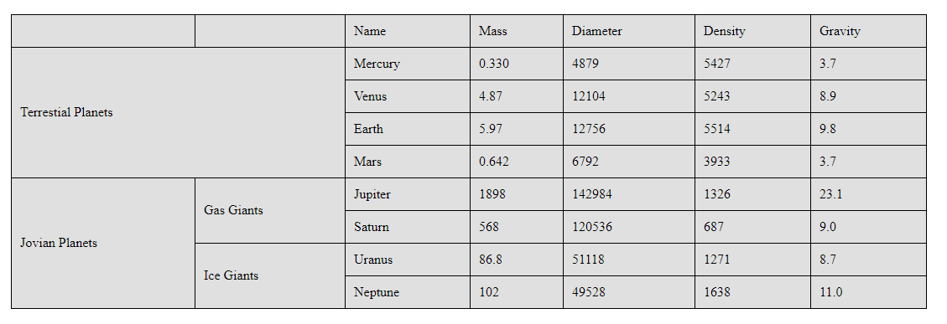

**Code:**

<!DOCTYPE html>

<html>

<head>

<title>Q4</title>

<style>

body{

padding:0px;

margin:0px;

}

table,tr,td{

border: 1px solid black;

border-collapse: collapse;

padding:10px;

}

</style>

</head>

<body>

<table style="width:80%;margin:auto;margin-top:100px;background-color:#E0E0E0;">

<th>

<td></td>

<td>Name</td>

<td>Mass</td>

<td>Diameter</td>

<td>Density</td>

<td>Gravity</td>

</th>

<tr>

<td rowspan="4" colspan="2">Terrestial Planets</td>

<td>Mercury</td>

<td>0.330</td>

<td>4879</td>

<td>5427</td>

<td>3.7</td>

</tr>

<tr>

<td>Venus</td>

<td>4.87</td>

<td>12104</td>

<td>5243</td>

<td>8.9</td>

</tr>

<tr>

<td>Earth</td>

<td>5.97</td>

<td>12756</td>

<td>5514</td>

<td>9.8</td>

</tr>

<tr>

<td>Mars</td>

<td>0.642</td>

<td>6792</td>

<td>3933</td>

<td>3.7</td>

</tr>

<tr>

<td rowspan="4">Jovian Planets</td>

<td rowspan="2">Gas Giants</td>

<td>Jupiter</td>

<td>1898</td>

<td>142984</td>

<td>1326</td>

<td>23.1</td>

</tr>

<tr>

<td>Saturn</td>

<td>568</td>

<td>120536</td>

<td>687</td>

<td>9.0</td>

</tr>

<tr>

<td rowspan="2">Ice Giants</td>

<td>Uranus</td>

<td>86.8</td>

<td>51118</td>

<td>1271</td>

<td>8.7</td>

</tr>

<tr>

<td>Neptune</td>

<td>102</td>

<td>49528</td>

<td>1638</td>

<td>11.0</td>

</tr>

</table>

</body>

</html>